

International Journal for Modern Trends in Science and Technology
Volume: XX, Issue No: XX, April 2026
ISSN: 2455-3778
http://www.ijmtst.com

A Multimodal Deep Learning Framework for AI - Generated Content Detection

SK. Arifa¹ | Y. Rishitha²| Y. Avinash Reddy³ | P. Abhilash⁴ |P. Ramesh Babu⁵

^{1,2,3,4} Department of CSE(Data Science), Bapatla Engineering College, Bapatla, Andhra Pradesh, India.
⁵Department of CSE(Data Science), Bapatla Engineering College, Bapatla, Andhra Pradesh, India.

To Cite this Article
Shaik Arifa, Yenuganti Rishitha, Yakkanti Avinash Reddy, Polasapalli Abhilash, Padamata Ramesh Babu “A Multimodal Deep Learning Framework For AI-Generated Content Detection” International Journal for Modern Trends in Science and Technology, Vol. xx, Issue xx, Month Year, pp.-xx-xx.

ABSTRACT

This paper presents a multimodal framework developed to identify whether digital content is created by humans or generated using artificial intelligence across text, images, audio, and video formats. With the increasing use of generative tools, telling apart real and synthetic content has become more difficult in everyday situations. The proposed system brings together multiple detection modules, where each module examines different characteristics of the input data. Text is evaluated through writing patterns and variation, images are checked for structural and texture differences, audio is analyzed based on sound behavior, and video is studied by observing frame level changes. Instead of depending on a single factor, the system combines all observations to produce an overall likelihood value along with a confidence level. The framework is designed to be simple, consistent, and useful in practical situations where quick and reliable verification of digital content is required by users and organizations in practice.

KEYWORDS: Multimodal Deep Learning, AI-Generated Content Detection, Deepfake Detection, Digital Media Forensics, Convolutional Neural Networks, MFCC Features, Explainability Heatmaps, Disinformation Detection, Cybersecurity.

Copyright © 2017 International Journal for Modern Trends in Science and Technology
All rights reserved.

Introduction
In recent years, generative artificial intelligence has become widely used across many applications. Tools that generate text, images, audio, and video can now produce content that closely resembles human-created data. Because of this, it is often difficult to clearly identify whether content is created by a person or generated by an AI system. While these technologies have improved productivity and creativity, they have also introduced challenges such as misinformation, identity misuse, and reduced trust in digital content.

There are several real-world examples where synthetic content has been misused. Deepfake
videos and voice-cloning techniques can be used to mislead people or commit fraud. In addition, AI-generated text is sometimes used in academic and professional work without proper disclosure. These issues highlight the need for reliable methods to verify the authenticity of digital content.

Most existing detection methods focus on a single type of data, such as text or images. However, in real-world scenarios, content often exists in multiple formats together. To address this limitation, this work proposes a multimodal system that can analyze text, images, audio, and video within a single framework.
The system identifies patterns that differ between human-created and AI-generated content and provides a confidence score instead of a simple binary output, making the results easier to interpret and more useful in practical applications.

Literature Review
Many researchers have worked on detecting AI-generated content, but most approaches focus on only one type of data such as text, images, audio, or video. Because of this, they are not always effective in real-world cases where multiple formats are combined.
For text, methods based on writing style and probability patterns were used, but newer AI models produce more natural text, making detection harder. Image-based methods try to identify visual issues like texture or color inconsistencies, but their performance drops with advanced generation techniques. Similarly, audio detection relies on pitch and frequency patterns, while video methods analyze frame-level changes, both of which face challenges with modern AI outputs.
Overall, existing methods work in limited scenarios, but there is still a need for a system that can handle multiple data types together.

Table 1: Comparative summary of existing detection approaches
Scientists | Approach Type | Method Description | Limitation
Ippolito et al. (2020) | Text-based (Unimodal) | Language model perplexity to identify AI-generated text | Fails on advanced LLMs; cannot handle non-text media
Gehrmann et al. (2019) | Text Stylometry | Analyses stylistic and statistical patterns in generated text | Bypassed by paraphrasing or fine-tuned models
Frank et al. (2022) | Image-based (Unimodal) | Detects frequency and spectral artifacts from GANs | Drops on unseen generators or compressed images
Korshunov & Marcel (2018) | Audio-based Detection | Analyses spectral inconsistencies in synthetic speech | Poor generalisation to modern TTS systems
Agarwal et al. (2021) | Video Deepfake Detection | Temporal and motion inconsistency across frames | High computational cost; vulnerable to frame attacks

System Architecture
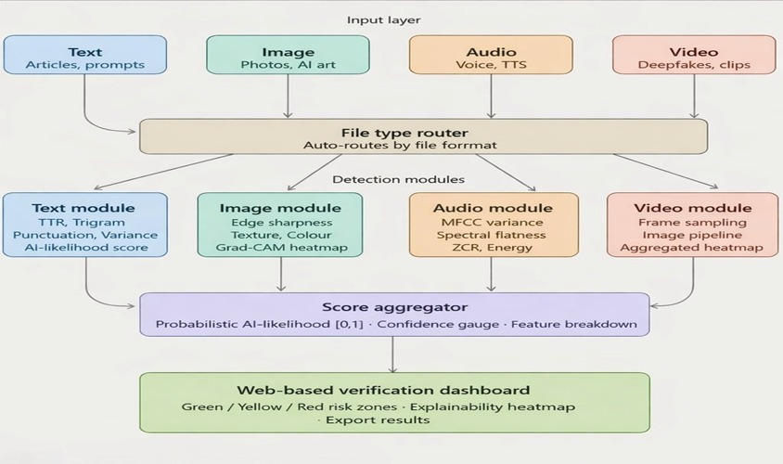

Figure 1. Architecture of the Multimodal AI Content Detection System

The system is designed to determine whether a given content is produced by a human or generated using artificial intelligence. It works by handling different types of data such as text, images, audio, and video in one place instead of treating them separately.
At the beginning, the system takes input in different formats like text files, images, audio clips, or videos. Based on the file type, it automatically sends the data to the correct module. This makes the process simple and avoids manual selection.
Each module focuses on one type of data. The text module looks at writing patterns, repetition, and sentence variation. The image module checks visual details like edges, texture, and color changes. The audio module studies sound features such as pitch, frequency, and energy levels. The video module breaks the video into frames and checks for small inconsistencies over time.
In simple terms, the system tries to understand patterns in data and compare them to typical human behavior. Once all modules complete their analysis, the results are combined to generate a final score.
At the end, the system shows the result in a dashboard, along with a confidence score and some basic explanation so that the output is easier to understand.

Methodology
In this project, we tried to use a multimodal approach where different types of data are handled separately and then combined. Instead of depending on only one type of content, the idea was to check text, images, audio, and video together.
There are separate modules for each type of data. Each one gives its own score, and later all of them are combined. The weights (w₁, w₂, w₃, w₄ and α, β, γ, δ) were not fixed initially and were adjusted based on testing results.

Text Detection Module
For text, the focus is more on how the writing looks overall rather than just the words. Sometimes AI text feels a bit repetitive or too consistent, while human writing usually has small variations.
TTR = V / N
Rₜ = N_rep / N_tri
CV = σ / μ
P_d = N_var / N_total
Final Text Score
S_text = w₁(1 − TTR) + w₂Rₜ + w₃(1 − CV) + w₄(1 − P_d)

Image Detection Module
For images, the system checks simple visual patterns. In many cases, generated images look slightly smoother and less natural.
V_edge = Var(∇²I)
T_c = N_low / N_blocks
C_v = σ(H)
Final Image Score
S_image = w₁(1 − V_edge) + w₂T_c + w₃(1 − C_v)

Audio Detection Module
In audio, we look at things like pitch and energy changes. Human speech usually varies naturally, but generated audio can sound a bit more steady.
V_mfcc = Var(MFCC_t)
SF = Geometric Mean / Arithmetic Mean
ZCR_v = Var(ZCR_t)
E_v = Var(E_t)

Final Audio Score
S_audio = w₁(1 − V_mfcc) + w₂SF + w₃(1 − ZCR_v) + w₄(1 − E_v)

Video Detection Module
For video, frames are checked one by one. If there are unusual changes between frames, it may indicate generated content.
S_i = S_image(f_i)
S_video = (1/n) × Σ S_i
T_v = Var(S_i)

Score Aggregation
After everything is processed, all scores are combined.
S_final = αS_text + βS_image + γS_audio + δS_video
Confidence = S_final × 100
Sometimes the system may not be fully accurate, but it still gives a reasonable estimate.
Classification Thresholds
0–33% → Human-generated
33–66% → Uncertain / Mixed
66–100% → AI-generated

System Requirements

A. Functional Requirements
The system should detect AI-generated content from text, images, audio, and video. Users can upload files, and the system returns results with an AI score and confidence value. For images and videos, important regions are highlighted to help understand the result. Outputs can also be saved if needed.
B. Non-Functional Requirements
The system is expected to work quickly. Text processing takes less time, while image, audio, and video analysis may take slightly longer depending on input size. All processing is done locally to maintain privacy.
C. Hardware Requirements
The system can run on a basic setup with an i3 processor and 8 GB RAM. Better performance can be achieved with higher specifications like i5/i7 and a GPU.
D. Software Requirements
The system is implemented using Python with libraries such as NumPy, OpenCV, librosa, and PyTorch. It supports Windows, Linux, and macOS.

RESULTS AND SYSTEM OUTPUTS
The proposed system was evaluated using multiple types of digital content including text, images, audio, and video. Each module produces a probabilistic output along with interpretability insights.

Text Detection Results
The text analysis module evaluates linguistic structure, fluency, and variability to classify content.

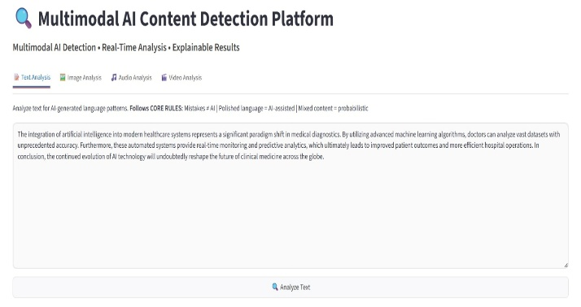

Figure 2. Structured text input with formal language.

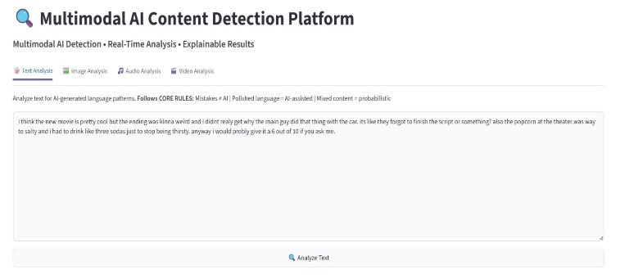

Figure 3. Informal human-written text sample.

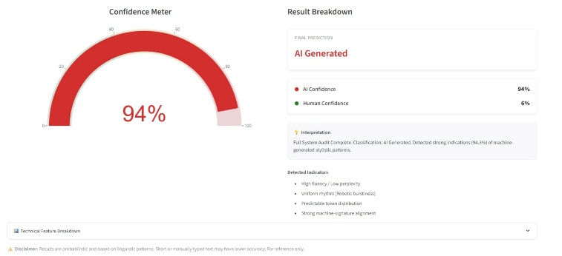

Figure 4. AI-generated classification result for structured text.

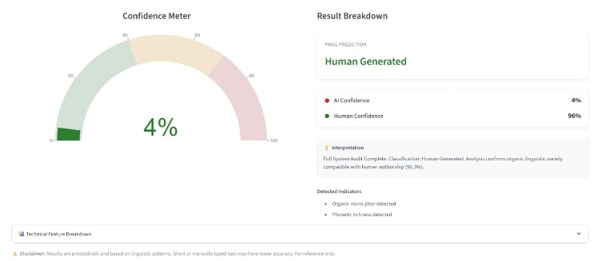

Figure 5. Human-generated classification result.

B. Image Detection Results
The image module analyzes texture patterns, edge distribution, and visual consistency.

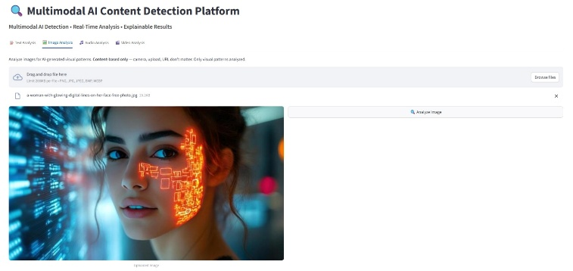

Figure 6. AI-generated facial image with synthetic visual features

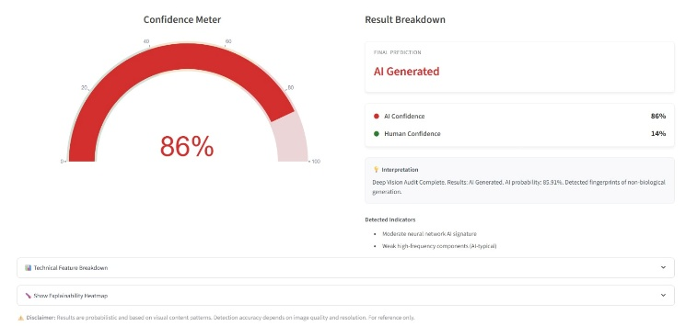

Figure 7. AI classification result for synthetic image.

C. Audio Detection Results
The audio module evaluates MFCC features, spectral flatness, and temporal consistency.

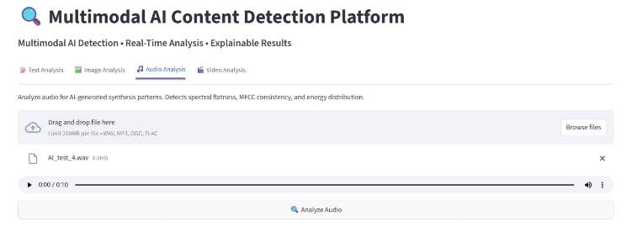

Figure 8. AI Audio input sample uploaded for analysis.

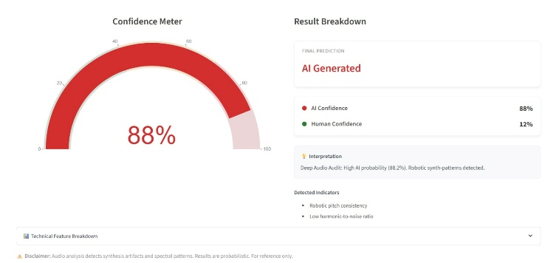

Figure 9. AI-generated audio detection result.

D. Video Detection Results
The video module analyzes temporal consistency, frame coherence, and deepfake artifacts.

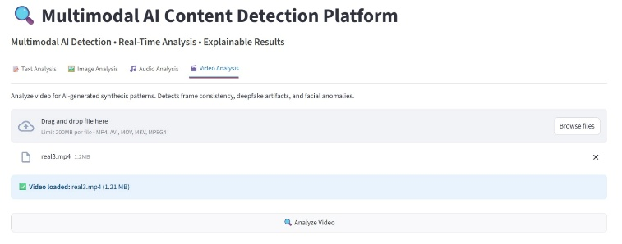

Figure 10. Real-world video input for analysis.
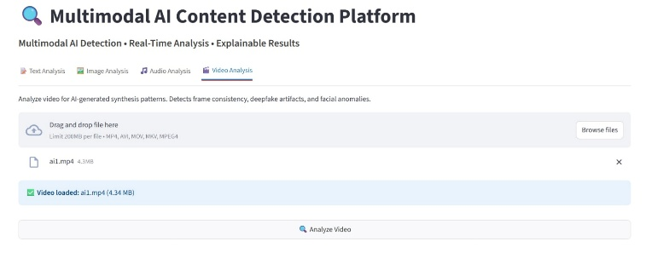

Figure 11. AI-generated video input for analysis
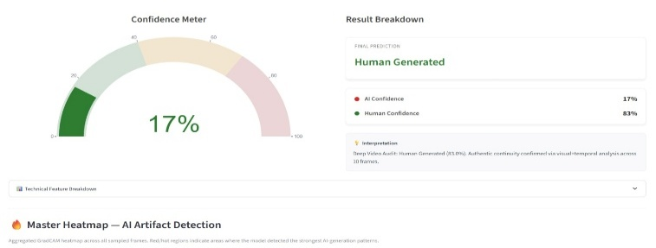

Figure 12. Human-generated video classification result.
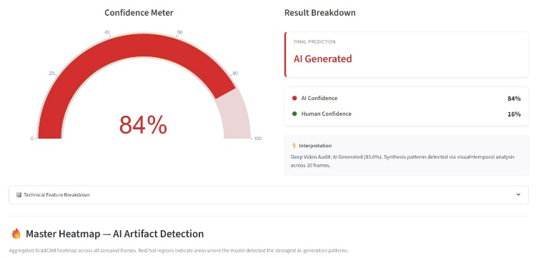

Figure 13. AI-generated video classification result.

E. System Output Dashboard

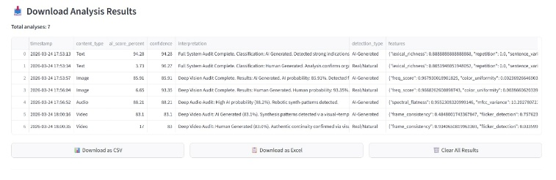

Figure 14.Centralized Analysis Dashboard.

Table 2: Detection Performance Summary Across Modalities
Modality | Feature method | Dataset used | Approx accuarary | Processing time
Text | TTR, Trigram, Punctuation | Human-or-AI Text Dataset | ~72–78% | < 1 second
Image | Edge, Texture, Color + Heatmap | CIFAKE Dataset | ~74–80% | 1–2 seconds
Audio | MFCC, Spectral Flatness, ZCR | ASVspoof / Deepfake-Audio | ~70–76% | 2–3 seconds
Video | Frame-sampling + Image features | AV-Deepfake1M / Celeb-DF | ~68–74% | 5–10 seconds

Conclusion
In this work, we developed a multimodal system to detect AI-generated content across text, images, audio, and video. Instead of focusing on a single type of data, the system combines multiple inputs and analyzes them together. This makes the overall detection process more reliable in practical situations.
Each module in the system looks at different patterns. For example, text is checked based on writing variation, images are analyzed using visual features, audio is examined through sound patterns, and video is evaluated using frame-level changes. These observations are then combined to produce a final score along with a confidence value.
The results show that the system can reasonably distinguish between human-created and AI-generated content. The inclusion of simple explanations, such as feature-based outputs and visual highlights, helps in understanding how the decision is made.
Overall, the system provides a useful and flexible approach for content verification. It can be applied in areas like misinformation detection, digital forensics, and cybersecurity. While the system may not be perfect in every case, it still offers a practical solution for identifying AI-generated content in real-world scenarios.

Acknowledgment
We would like to thank Dr. P. Ramesh Babu, Associate Professor in the Department of Data Science at Bapatla Engineering College, for his guidance and support throughout this work. His suggestions and inputs helped us improve the project in many ways.
We also thank the Department of Computer Science and Engineering (Data Science) and Bapatla Engineering College for providing the required facilities and a supportive environment to complete this work.
Finally, we would like to thank our friends and classmates for their help and feedback during the development of this project.

References
- C.-S. Sung, J.-C. Chen, and C.-S. Chen, "Hearing and seeing abnormality: Self-supervised audio-visual mutual learning for deepfake detection," in Proc. IEEE Int. Conf. Acoustics, Speech and Signal Processing (ICASSP),2023,DOI: 10.1109/ICASSP49357.2023.10095247.
- Y. Du, Z. Wang, Y. Luo, et al., "CAD: A general multimodal framework for video deepfake detection via cross-modal alignment and distillation," arXiv preprint arXiv:2505.15233, 2025.
- D. Ippolito, D. Duckworth, C. Callison-Burch, and D. Eck, "Automatic detection of generated text is easiest when humans are fooled," in Proc. ACL, 2020.
- S. Gehrmann, H. Strobelt, and A. Rush, "GLTR: Statistical detection and visualization of generated text," in Proc. ACL, 2019.
- J. Frank, T. Eisenhofer, L. Schoenherr, A. Fischer, D. Kolossa, and T. Holz, "Leveraging frequency analysis for deep fake image recognition," in Proc. ICML, 2022.
- P. Korshunov and S. Marcel, "DeepFakes: A new threat to face recognition? Assessment and detection," arXiv preprint arXiv:1812.08685, 2018.
- S. Agarwal, H. Farid, O. Fried, and M. Agrawala, "Detecting deep-fake videos from appearance and behavior," in Proc. IEEE Int. Conf. Computer Vision Workshops, 2021.
- Kaggle Fake News Dataset (2022) — for AI text detection benchmarking.
- FaceForensics++, DeepFake Detection Challenge (DFDC), Celeb-DF — image and video deepfake detection datasets.
- ASVspoof Challenge Dataset, VoxCeleb — for detecting cloned and synthetic audio.

